Fort Christina
www.nps.gov/places/fort-christina.htm

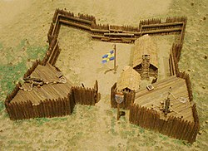
It was here at “The Rocks”, the site of the natural wharf of rock located at the confluence of the Brandywine Creek and the Christina River approximately 2miles upstream from the mouth of the Christina on the Delaware that the Swedes and Finns abord the Kalmar Nyckel and Grip Fogel first landed in 1638.
After the Swedes purchased land from the Lenape Indians, they built Fort Christina and established the colony of New Sweden, a thriving community based on fur-trading and farming. Fort Christina was the first permanent European settlement in the Delaware Valley and the first in what would become Delaware – the future First State of the United State of America. Fort Christina was the first Swedish settlement in North America and the principal settlement of the New Sweden colony.

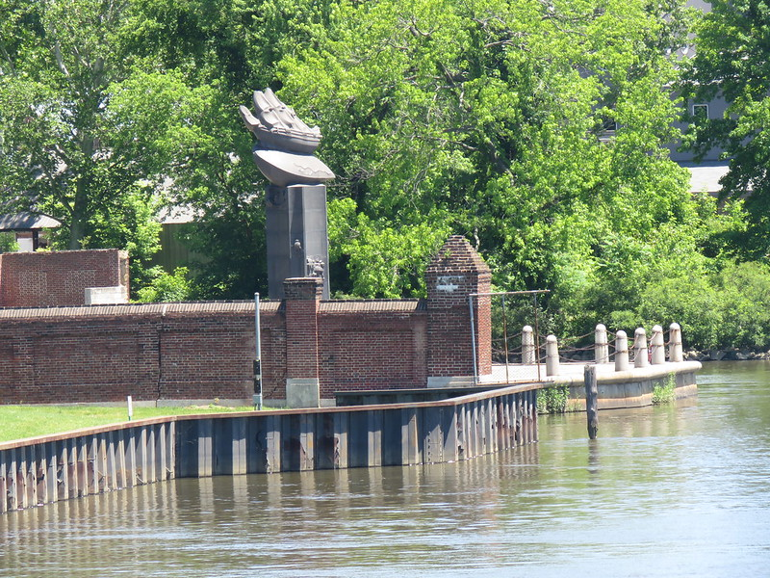
In 1938, the State of Delaware created Fort Christina Park which contained The Rocks of the first landing and a new Swedish Tercentenary Monument to celebrate the 300th anniversary of the Swedish colonization of the area. The monument was a gift of the people of Sweden to the people of the United States and depicts the Swedish colonial vessel, Kalmar Nyckel, surmounting a column of Swedish black granite. The monument was crafted in 1938 by renowned Swedish-American sculptor Carl Milles, containing several bas relief's that provide insight into the unique history surrounding the Fort.
On June 27, 1938 President Franklin D. Roosevelt dedicated the park and the monument. Guests included U.S. Secretary of State Cordell Hull, Swedish Crown Princess Louise, Swedish Royal Prince Gustaf Bertil, as well as a large delegation from Finland
In July, 2016, Fort Christine became a National Historic Landmark.

